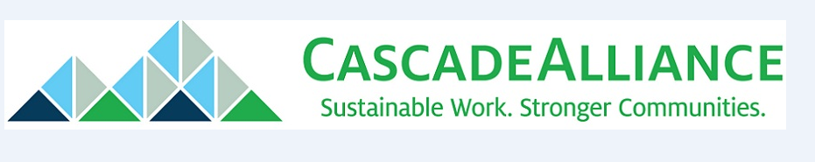

The State of Online Book Sales
September 15, 2014
Prepared by Sophia Bennett for The Cascade Alliance
Funded by The Robert Wood Johnson Foundation

The state of book publishing, reuse and recycling
Prepared for the Cascade Alliance

The trend toward ebooks has broad implications for the publishing industry, but it affects book reuse and recycling organizations as well. Are the paper book’s days numbered? Will there even be a book recycling industry in a few years?

Experts seem to agree that physical books are not going away anytime soon. The second-hand book business is going strong, with many people turning to online sources to get their books rather than traditional bookstores. Book reuse and recycling should remain a viable industry indefinitely.

What’s happening in the publishing industry?

For a while it was popular to bemoan the death of the novel and of reading in general, especially among young people. The huge success of J.K. Rowling’s Harry Potter series was an early step in proving that theory wrong. In 2008, publishing industry revenues were $13 billion; in 2012 they were nearly $15 billion. (Source: New Republic)

Ebooks are definitely making inroads. In 2008, sales of ebooks were $64 million. In 2012 they were over $3 billion. Audiobooks are growing at the fastest rate of any medium. (Source: New Republic)

However, trade paperbacks continue to be the top-selling format for books, followed by ebooks, then hardcover books. The first time ebooks outsold a printed format was 2011, when ebook sales overtook hardcover sales.

The growth in ebook sales is also slowing down. The Washington Post reports that the increase in ebook sales was only 5 percent in 2013, as opposed to 252 percent in 2010. The author compares paper and ebooks to television and radio; although television passed radio in popularity in the 20th century, radio still hasn’t gone away and remains a very viable industry.

Some readers aren’t likely to give up their paper books

A piece published on the website Mashable gives several reasons why ebooks will never entirely replace printed books. Books have a certain beauty about them, almost like art, that people value. They also like the smell, the weight, the way a book feels in their hands. Plenty of people collect books, which is hard to do if you only buy ebooks. Author Rob Hart is quoted in the article saying, “Digital technology is funny — you own an ebook, but you don't ... You're paying for the right to access data.” In sum, the author states that printed books are an entirely different animal than an ebook, and both camps continue to have fans.

One of the groups with the most enthusiasm for print books is parents, who worry that any more screen time may be bad for their children. Kids and young adults may be the fastest-growing segment of the digital book market, but popular children’s publisher Scholastic gives pros and cons to letting kids use ebooks exclusively. While they can help learners who are more visual and provide kids with greater chances for interaction, the lights and songs sometime associated with ebooks can be a distraction. Plus, “cuddling with a parent over a book or gathering around the teacher for story time helps kids associate reading with nurturing.” Perhaps that’s why 68 percent of parents say they would rather their kids read paper books.

What happens with textbooks is definitely something to watch in coming years. Colleges are encouraging electronic textbooks as a good alternative to traditional books – and one that can cut costs for students in a time of rising tuition. K-12 schools have been slower to adopt etextbooks, although some are beginning to experiment with it. But as with consumer publications, it seems unlikely that paper textbooks will entirely go away. A 2008 study by the Student Public Interest Research Groups reported that 75 percent of students surveyed said they preferred paper textbooks to ebooks, and that 60 percent would buy a paper textbook even if they could get an electronic version of the same book for free.

Used books are still in high demand

The last time anyone studied used book sales in the United States was 2005, and the figures looked very promising. The Book Industry Study Group reported that used book businesses had $2.2 billion in sales and sold 111 million books. Used book sales accounted for 8.4 percent of total consumer spending on books.

A 2010 report by Publishers Weekly shared anecdotal evidence that used books are still in high demand. Stores in St. Louis, Los Angeles and other major cities are increasing the shelf space devoted to used books. Alibris, which provides software to help used book sellers manage their sales across multiple online retailers, saw double-digit growth in 2010.

The 2005 Book Industry Study Group report credited the big increase in used book sales to the ability to buy and sell books online, and that trend is definitely continuing today. The firm Bowker Market Research reports that online sales accounted for 44 percent of consumer spending on books. In 2011 that figure was 39 percent. The Association of American Publishers reports that book sales through online retailers rose 21.3 percent in 2012, to $6.93 billion, while sales through bricks-and-mortar outlets fell 7 percent to $7.47 billion. As the graph below shows, sales at online book seller Amazon are far surpassing those at traditional book stores like Barnes & Noble.

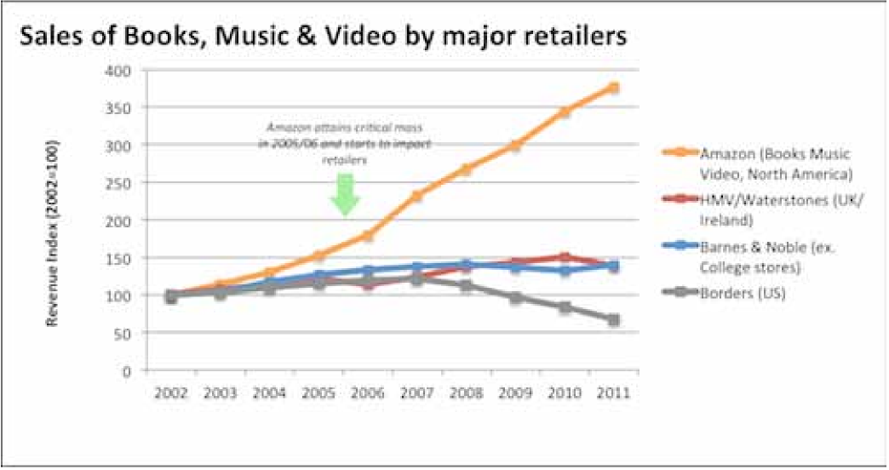

Sources:
Books Don’t Want to be Free: How Publishing Escaped the Cruel Fate of Other Culture Industries, New Republic (http://www.newrepublic.com/article/115010/publishing-industry-thriving)

Ebook sales are leveling off. Here’s why, Washington Post. (http://www.washingtonpost.com/blogs/wonkblog/wp/2013/08/08/ebook-sales-are-leveling-off-heres-why/)

Why Printed Books Will Never Die, Mashable (http://mashable.com/2013/01/16/ebooks-vs-print/)

Ebooks vs. Print: What Parents Need to Know, Scholastic (http://www.scholastic.com/parents/resources/article/developing-reading-skills/ebooks-vs-print-what-parents-need-to-know)

Course Correction, Student Public Interest Research Groups (http://www.studentpirgs.org/reports/course-correction)

Rapid Growth in Used Book Market Driven By the Internet, Book Industry Study Group (https://www.bisg.org/news/press-releaserapid-growth-used-book-market-driven-internet)

Used Books: On the Up and Up, Publishers Weekly (http://www.publishersweekly.com/pw/by-topic/industry-news/bookselling/article/44091-used-books-on-the-up-and-up.html)

